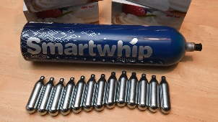
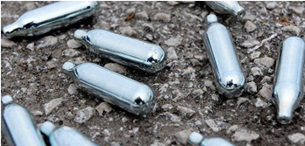
DRUG ALERT – Nitrous oxide

Overview – Nitrous oxide is a gas used medically as an anaesthetic. It is also used within catering as the propellant in whipped cream chargers. Some people use it as a recreational drug to get high, usually inhaled from a balloon. It acts as a ‘depressant’ (similar to alcohol), in that is slows down the body’s system and leads to feelings of relaxation or happiness this has given rise to its nickname of ‘laughing gas’.
General reported effects on your Body
- An immediate but short-lived euphoric high, relaxing effect, slowing of the body’s system, fits of giggles and laughter, sound distortions and hallucinations, it can also; give users a severe headache, cause dizziness, impair the ability to think straight, and cause short-lived but intense feelings of paranoia.
Physical Health Risks & Harm Reduction – There are many risks involved with inhaling nitrous oxide which include; heavy use causing the body to be starved of oxygen leading to suffocation or unconsciousness, having accidents whilst under the influence of nitrous oxide, heart failure (this risk is increased if sudden exercise is taken after using), choking on vomit especially if unconscious or drunk, nitrous oxide inactivate vitamin B12 leading to nerve damage (there have been increasing numbers of hospital reports of this, possibly due to the increasing availability of larger canisters). However, if you choose to take it, it is advised to follow this guidance:-
- Be careful where you get your nitrous oxide from. Make sure you are not being supplied a more dangerous gas such as butane.
- Don’t inhale directly from the charger.
- Take care when discharging canisters. Don’t let the gas come into contact with your skin as the extreme cold can cause burns to your skin.
- Don’t use a mask or put a plastic bag over your head.
- Don’t overdo it. If you are planning on using more than one balloon let your body recover in between.
- Eat to replenish your levels of vitamin B12, eggs, cheese, marmite etc. are good. This is particularly important if you are vegetarian or anaemic.
- Don’t take nitrous oxide on your own. Stay with others and have someone agree to stay sober to keep an eye on the others.
- Don’t mix with other drugs or drink alcohol.
- Stay in a safe environment and have a plan for how you’re going to get home.
- Ensure you are in a well-ventilated area.

For drug and alcohol treatment, advice and support call START on 0114 305 0500 or drop into the service at 42 Sidney Street, Sheffield S1 4RH. In an emergency, call 999.

